A DfES designated Training School


“Roots of happiness
branches to learning”
Garswood Primary School



Checklist for Teacher Trainee’s

Day 1
Take a tour of the school with a member of staff | To be confirmed on the day | Pamela Potter  Head teacher
Read through trainee handbook | Found in trainee handbook | Marie Chadwick  School Business Manager
Fill in contact sheet and return | Found in trainee handbook
Read initial Teacher Training Policy | Found in Trainee handbook
Obtain username and password for the networked computers | Schools ICT technician  (a call will need to be logged) | Marie Chadwick  School Business Manager
Meet with class teacher and mentor | Information obtained from Marie Chadwick or Pamela Potter | Individual to trainee
On completion of serial or block experience
Complete Evaluation form | Found in trainee handbook | Marie Chadwick/  SLT teacher
Obtain final report form from mentor | Individual to trainee

If you have any questions or enquiries during your block practice or serial days you can always talk to your class teacher or mentor.

Could all forms be returned to Marie Chadwick as soon as possible please?
Garswood Primary School
A DfES designated Training School

Full name _____________________________________________

HEI______________________ Course______________________
Link Tutor name_______________________________________
Contact number________________________________________
Serial/Block (delete as appropriate)
Initial/ Developmental/Synoptic/ other (delete as appropriate)
Paired/group/individual placement (delete as appropriate)
Class teacher_________________________Mentor___________________
Placement dates: From__________________To___________________
Term Time address____________________________________________
______________________________________________________________
Telephone number____________________________________________
Mobile phone number_________________________________________
E-mail________________________________________________________
Please note any medical condition(s) that you feel it is important to share with school

Next of kin __________________________________________________

Contact telephone number____________________________________

If you know that you are going to be absent please inform school at the earliest opportunity.

I confirm that it is my responsibility to familiarise myself with school policies, with particular emphasis on Safeguarding and Health and Safety and I will ensure these policies are adhered to at all times.

Signed: _________________________________ Date: ________________________

Garswood Primary School
A DfES designated Training School

We would like to take this opportunity to thank you for the positive contributions that you have made to the lives of the children and staff at Garswood School. We hope that your time with us has been worthwhile and enjoyable.

As we know you will have learned, feedback is an important way to learn about yourself and ways in which you can improve. With this in mind we would like you to help us to improve by completing this short evaluation form at the end of your practice.

Name_________________________ Class _______ Date_______________
HEI_____________________ Course________________________________
Serial/Block (delete as appropriate)
Initial/ Developmental (delete as appropriate)
/Synoptic/ other
Paired/group/individual placement (delete as appropriate)

Final grade_____________ (if appropriate)
Class teacher__________________________________________________ Garswood Mentor_____________________________________________

- What has been valuable about your experiences at Garswood?

- Is there anything that could have been done differently to make your stay with us more useful or more enjoyable?

- Do you have any comments to make about the handbook you received when you arrived at the school?

- Could you please comment on the quality of support that you have received from your mentor?

- Could you please comment on the quality of support that you have received from your class teacher?

- Are there any other comments that you would like to make?

Please circle your ratings for the following:

(1 – Outstanding - - - - 5 unsatisfactory)

Quality of support from mentor 1 2 3 4 5
Quality of feedback from mentor 1 2 3 4 5
Quality of support from class teacher 1 2 3 4 5
Quality of feedback from class teacher 1 2 3 4 5
Quality of resources available in the classroom 1 2 3 4 5
Quality of Induction (handbook and tour) 1 2 3 4 5
Organisation of teaching time
/non-contact time 1 2 3 4 5
Facilities (parking, staff room, toilets) 1 2 3 4 5
Commitment to children and learning (staff) 1 2 3 4 5
Commitment to learning (children) 1 2 3 4 5

Thank you for taking the time to complete this evaluation form. May we take this opportunity to wish you well in your future career.

Goodbye and good luck.

Welcome to Garswood

Welcome to Garswood Primary School. We hope that your stay with us is a happy and valuable one. At Garswood we appreciate that trainees come from a variety of backgrounds and as such we look forward to the benefit and experience that you can bring to our pupils. During your stay with us we want you to feel that you are a professional colleague – albeit one who is “learning the trade”, and would hope that you would respond to this by entering into the life of the school as fully as you can.

Aims of the School

We are concerned at Garswood to teach more than the subjects of the National Curriculum. Garswood School aims to offer its community a way of learning for life based on the broadest range of experiences.

We encourage both independence of mind and spirit, and the recognition of individual and collective responsibility. We wish to include everyone in the task of providing our children with the knowledge and skills to take full advantage of the opportunities offered to them. We give pride of place to respect for oneself, and respect for others.

All this reflects a concern to focus on what children will need as citizens in a changing world. As a result the broad aims of the school are based around three key ideas.

We want our children to become:

- successful learners, who enjoy learning and achieve well

- confident individuals, able to live a safe, healthy and fulfilling life

- active and responsible citizens who will make a positive contribution to the well-being of present and future generations

To achieve these aims we are committed to working with them and others as partners, to foster an enjoyment of learning, to motivate, and teach our children that determination is needed to succeed.

Children will learn the basic skills of literacy, numeracy and information technology. They will learn to communicate effectively, to be creative and to develop enquiring and open minds. They will be encouraged to explore the world around them, to take risks, be resilient and to learn from their mistakes.

At Garswood we firmly believe that children should have opportunities to learn outside the classroom through visits, visitors and through effective use of the school grounds and local community. We actively encourage all trainee teachers to plan effective opportunities for LOTC whilst on their placement.

They will need a supportive environment which promotes both independent and collaborative learning. We will give them lots of opportunities to take the initiative and to form good relationships. We will collectively value each child. Through a growing self-belief and self worth each child will learn to resist negative pressures, and to make informed choices.

To achieve all this we will need to inspire our children to delight in learning.

We will celebrate talents and ambitions, promote healthy lifestyles and help children understand that respect for the beliefs, needs and rights of every single person is an essential part of a civilised, inclusive and multicultural society.

In short we will together empower our children to believe they can change things for the better.

It is important to remind ourselves just what it is that makes our school special –

Every child matters to the Garswood family.

The school has developed policies and practices to deliver these aims.

Facts About Our School

Head Teacher Pamela Potter
Deputy Head Teacher Andrew Yearsley
Assistant Headteacher Lucy Myatt

Our address:
Garswood Primary School
Hamilton Road
Garswood
Wigan
Lancs
WN4 OSF
Tel: 01744 678290
Fax: 01744 678294
Email: garswood@sthelens.org.uk
Website: www.garswoodprimary.co.uk

Garswood Primary and Nursery School is an infant and junior school with a mixed intake of children who live locally and who travel to the school from other areas.

Garswood is a non-smoking school.

The School Mentors

We are very lucky that all of the teachers are trained mentors. Our commitment to mentoring has been recognised as we are a Training School. We have also been recommended by Edge Hill School of Education to be a Premier Partnership School.

You will have been designated a mentor before you arrive at our school. The role of the mentor is to ensure you settle into the life of the school and to guide you at all stages of your teaching practice, from the initial visit, through to the planning stages and shared observations with the class teacher to the eventual evaluation. Your mentor and your class teacher will be your first port of call, so please do not hesitate to go to them for information or to discuss your concerns and worries, should you have any. Garswood School is a friendly place and all of the staff at school will be happy to help you.

The School Team

Head Teacher Pamela Potter
Deputy Head Teacher Andrew Yearsley
Assistant Head Teacher Lucy Myatt
School Business Manager Marie Chadwick
Admin Assistant Beverley Lamb
Clerical Officer Ann Griffiths
Clerical Asst. Kay Wood
Caretaker Neil Molyneux

Class teachers
Nursery Sam Cripps
Foundation Stage YR Sue Bagshaw
Key Stage 1 Y1 Laura Meehan/Les Moon
Y2 Rachel Jenkinson
Key Stage 2 Y3 Lucy Myatt/Les Moon
Y4 Andrew Yearsley/Les Moon
Y5 Sarah Hattersley
Y6 Gill Wainwright

Learning Assistants
Lynne Hunter Amy Grimshaw
Barbara Dews Fiona Verron
Jill Braithwaite Katie Sheedy
Emma Rumsey Helen Evans
Karen Forshaw Samantha Finegan
Jessica Harrison Lucy Brown
Michelle Evans Emma Jackson
Hannah Livesley

Team work is essential to our success as teachers. Our infant classes are often team taught, which means the children have the opportunity to work with different teachers at different times of the day. If you are placed in an infant class this will be discussed further with you and you will have the opportunity to be a key part of the team during your stay with us.

All teachers work together with their parallel class teacher and Learning Assistants in order to plan the next steps in learning for the children in their care. The way this is done varies slightly from class to class and between year groups. This will be explained by your class teacher.

During your first day you will have the opportunity to meet the class teacher you will be working with and find out more specific details regarding the adults who will be working with you and how this is time-tabled.

What to Expect
When you arrive at Garswood, you will be given time to settle into our school. The School Business Manager or SLT Member, Lesley Moon will talk to you and give you this booklet. We will give you a tour of the school and show you the staff room, discuss tea and coffee arrangements, car parking and other practical matters. You will meet your class teachers and be able to talk about planning, schemes of work and the organisation of the class and the school day. We understand that you will have questions to which you will need the answers. We are happy to help with anything that you may need to know.

On your preliminary visits to Garswood, you will have specific information to find out. Please note that there is a wealth of information on our school website.

Documentation in School
You are welcome to look at any school policy document. Each teacher has a “policy file” which they will share with you at your request. It is your responsibility to familiarise yourself with school policies, with particular emphasis on Safeguarding and Health and Safety and I will ensure these policies are adhered to at all times. School policies include:

- Health and Safety
- Safeguarding and Child Protection
- Marking Policy
- Assessment Policy
- Behaviour Policy

When you begin your block practice, Marie Chadwick, the School Business Manager will issue you with a password for the computer network. This will allow you access to the “Trainee share” folder. Within this folder there is a policy folder containing all the school policies for you to peruse and download. It is important not to use the network under any other user name and not to share your password with anyone.

Security
If you are given a code for the internal doors, office and staffroom, it is important to keep these confidential so as not to compromise school security. Please ensure that you sign in and out as outlined by the School Caretaker on your initial visit. A key fob is used to enter the main building but for security reasons we are not at able to give these fobs to trainees. If you press the buzzer a member of staff will let you through to the main Reception.

The school has access to its own wireless technology that is available to staff only. We would appreciate it if you would not attempt to log onto the network via your own laptop, blackberry or mobile phone. Although protected by a code, all attempts to try and access the network, even unsuccessful ones will be logged. As I am sure you understand there is information about children on our network that should not be shared outside the school building for child protection reasons. Therefore the network must remain secure.

Safeguarding
It is everyone’s responsibility to safeguard the children in our care. It is important that before you begin work at the school or within the first day, you familiarise yourself with the Safeguarding and Child Protection Policy and ensure that it is adhered to at all times. Mr. Andrew Yearsley is the designated teacher for child protection. It is important that you alert Mr. Yearsley to any training needs you have in this area and it is expected that you undertake either the e-academy training or undertake safeguarding training which can be accessed through www.cwdcouncil.org.uk. This should be completed before you start work at the school or on the first day.

If you have any concerns over the safety or welfare of a child, it is of paramount importance that you discuss these with your class teacher or mentor and inform the designated teacher for Child Protection, Andrew Yearsley.

Please note the use of mobile phones is prohibited in the main body of the school. Phones must always be on silent. Any personal or professional phone calls or texts must only take place in the PPA area, Staff room, or Office at break-times.

It is of paramount importance that you understand that at all times it is a privilege to be in any school and experience its life at first hand. You must respect confidentiality at all times. What happens in school should not be discussed outside the school.

Please sign to confirm your understanding of the above points.

…………………………………………………………………..

Remember you are not alone at Garswood and all members of staff are willing to answer any queries you may have. We welcome every contribution you can make to our school. Thank you

Health and Safety
Please ensure that you are fully familiar with all the health and safety procedures in school and ensure that you ask to see copies of relevant risk assessments, particularly in relation to COVID 19. Risk assessments can be obtained from the School Business Manager and/or Head Teacher. Either of these people will be happy to discuss any health and safety matters with you.

You will find a notice in the PPA area regarding fire safety procedures including times of weekly fire alarm tests.

Harmful substances must not be brought on to site and any use of electrical appliances or specialist equipment must be discussed with the Head Teacher prior to its use. Any concerns you have should be discussed with the School Caretaker or Marie Chadwick.

Although the school will endeavour to ensure your health and safety during your time with us, it is also your responsibility to become familiar with operations and procedures, e.g. lifting and moving equipment and safe working practices. Please speak to the School Caretaker if you have any queries or would like further clarification on these matters.

Health and safety is very important – please make sure you read our school Health and Safety Policy. If a child (or adult) sustains an injury and you are a witness to this, you need to immediately report the accident to the Class Teacher. Accidents must be recorded in the appropriate format in the Class Accident Book. Please refer to the Health & Safety Policy for further details.

Times
You must contact school at the earliest opportunity if you know that you are going to be absent. The telephone number is at the front of this booklet. If you are absent, please try to ring by 3.00pm to let us know if you will be in the following day.

The children enter the building from the playground from 8.30am, staggered over three time-slots. As you are taking on the role of the teacher sometimes, at the end of playtimes, you will be asked to collect the children from the playground and taken into school in an orderly fashion.

At the end of the day children are collected by their parent from the classroom door, again, staggered over three time slots from 2.45pm – 3.30pm. Please ensure that any letters for the children to take home are distributed in good time before the end of the day.

It is often appropriate to meet with the teaching team at the end of the day to review your practice and discuss the children to inform your planning. Assessment for learning is critical to providing challenge and ensuring optimum opportunities for learning. Time to talk to all staff that have been in contact with the children over the day is important.

The whole school time-table is over the page for your ease of reference. Your class teacher will provide you with a more detailed time-table specific to the class in which you will be placed, which will detail hall times/computer suite times/outdoor games times and other organisational details.

Garswood Primary School – Weekly Timetable

 | Monday | Tuesday | Wednesday | Thursday | Friday
This year, for social distancing purposes, there will be a staggered start and end time to the day
Children will attend based on an alphabetical system - there will be three start and end times
8.30-8.45am 8.45am-9.00am 9.00am-9.15am
2.30pm-2.45pm 2.45pm-3.00pm 3.00-3.15pm
Nursery begins | 8.30am
Gate opens | 8.25am
Doors open | 8.29am
Register and Learning Session Begins | 8.30am -9.15am | 8.30am -9.15am | 8.30am -9.15am | 8.30am -9.15am | 8.30am -9.15am
Learning time

(Rec) Y4 & Y5 Playtime | 10.30am-10.45am
Y1,Y2 & Y3,Y6  Playtime | 10.30am-10.45am
Learning time

Nursery  Lunchtime | 11.30am – 12.00pm | 11.30am – 12.00pm | 11.30am – 12.00pm | 11.30am – 12.00pm | 11.30am – 12.00pm
Rec Lunchtime | 11.40am- 12.30pm
Y1 Lunchtime | 11.30am-1.00pm
Y2 Lunchtime | 12.10pm-1.00pm
Y3/Y6 Lunchtime | 12.15 – 1.00pm
Y4/5 Lunchtime | 11.45 – 12.30
Children will line up and be brought inside by midday supervisors and class teachers will be there to greet the children. Lessons will begin promptly.

Learning time
School Day Ends | Staggered off-site system is in place from 2.45 to 3.30pm to enable social distancing
After School Meetings | SLT |  |  | Staff meeting
Registration closes 15 minutes following the start of the session both in the morning and afternoon.

Lunch Time
You are welcome in the staff room. You are not required to remain on the premises but we do except a prompt start to the afternoon session. A school dinner may be ordered from the school office before 9.30am. There is a charge, please ask at the office for the current cost.

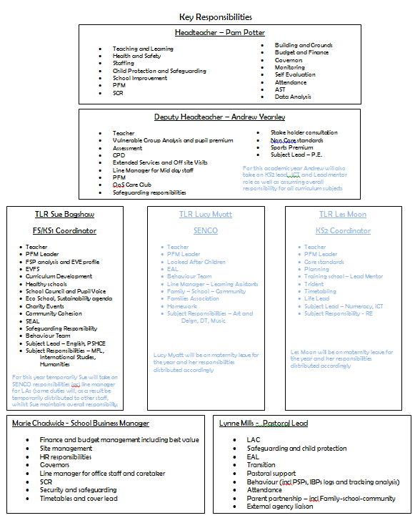
lease ensure that you wash and put away all crockery used at break times/lunch time. There is a shop, “Londis” nearby which sells sandwiches, pies, cakes etc. There is also chip shop around the corner.

Miss R. Jenkinson Teacher, Art and Design and Design and Technology, Forest Schools, School Travel Plan and Bike it
Mrs L Rollason Teacher, RE, Talented and More Able, School Shop
Mrs S. Hattersley Teacher, Science, Writing, PE, Eco-Schools and grounds, Archery lead, Forest Schools.
Mrs G. Mackenzie Teacher, Mathematics, European and International Links, Modern Foreign Language, Music, SLE (Maths Hub)
Mrs L. Meehan Teacher, History, Geography, PSHE, Forest Schools

Mrs S. Cripps Nursery Manager
Mrs S. Finegan Learning Assistant (Maternity Leave)
Miss A Grimshaw Learning Assistant
Mrs H Livesley Learning Assistant

Mrs. B. Lamb Administrative Assistant
Mrs A. Griffiths Clerical Officer
Mrs K. Wood Clerical Officer (Nursery)
Mrs L. Hunter Learning Assistant L3
Mrs B. Dews Learning Assistant L3
Mrs J. Braithwaite Learning Assistant
Mrs. K. Forshaw Learning Assistant
Mrs E. Rumsey Learning Assistant/KIDZ Club Afterschool lead.
Mrs L. Brown Learning Assistant/Midday Supervisor
Mrs J. Harrison Learning Assistant
Ms F. Verron Learning Assistant
Mrs H. Evans Learning Assistant
Mrs E Jackson Learning Assistant
Miss K Sheedy Learning Assistant
Mrs M Evans Learning Assistant

Mr. N. Molyneux Caretaker
Mrs K. Kendrick Cleaner
Mrs L. Moore Cleaner/Midday Supervisor

Mrs K. Hill Kidz Club Breakfast Club lead.
Mrs T. White KIDZ club assistant
Mrs H Gannon KIDZ club assistant

Mrs S. Boulton Midday Supervisor
Mrs I. Burrows Midday Supervisor
Mrs M. Peet Midday Supervisor/KIDZ club assistant
Mrs C. Lawrenson Midday Supervisor/KIDZ club assistant
Mrs S. Tully Midday Supervisor

If you would like to speak to any of the Curriculum Leaders or if you need more information about resources, please do not hesitate to ask in order to arrange a mutually convenient time. All staff will be happy to help.

Teaching Strategies
We view your teaching practice with us as an opportunity for you to develop your teaching strategies. We all learn at different rates and to be an effective teacher, there are many skills to master.

Your mentor and class teacher will work with you in structuring your development of teaching strategies. At college you will have discussed this and it would be useful to consider the teaching strategies vital for effective teaching. You may also have a Professional Profile in which to record your progress.

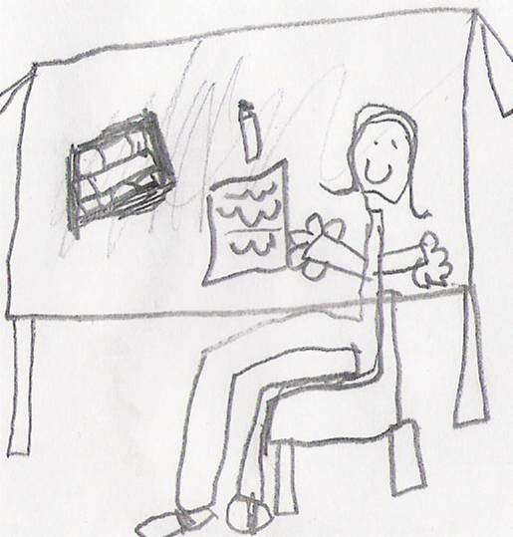
Classroom Procedures
As far as possible we would like you to maintain established classroom routines. The classroom environment is an important part of the whole teaching process and must be well organised at all times. You will be expected to be responsible for display areas (negotiated with the class teacher) and resource organisation. Your class teacher will plan with you a timetable that includes the widest range of subjects, but will definitely provide scope for you to teach aspects from your specialist subject.

You will be responsible for the marking of children’s exercise books and recorded work in files or on paper. It is in your interest not to get behind with the daily marking or assessment and record keeping. Please ensure that you use a black pen at all times and that you adhere to the school marking policy, unless marking extended writing then please use a green pen.

Good discipline is paramount to successful teaching. Corporal punishment or child contact is not allowed. The discipline is achieved through positive reinforcement of good work and behaviour. For incidents of poor behaviour, each class has an Incident Book. Please discuss how to use the Incident Book with your Class Teacher.

It is of paramount importance that you understand that at all times it is a privilege to be in any school and experience its life at first hand. You must respect confidentiality at all times. What happens in school should not be discussed outside the school except in a professional setting and then only in a way that does not identify any children involved.

Remember you are not alone at Garswood. If you have any problems, want a professional discussion or merely a chat – you only need to ask.

